Sử dụng độ đo Information Gain, xây dựng cây quyết định cho tập DL sau:

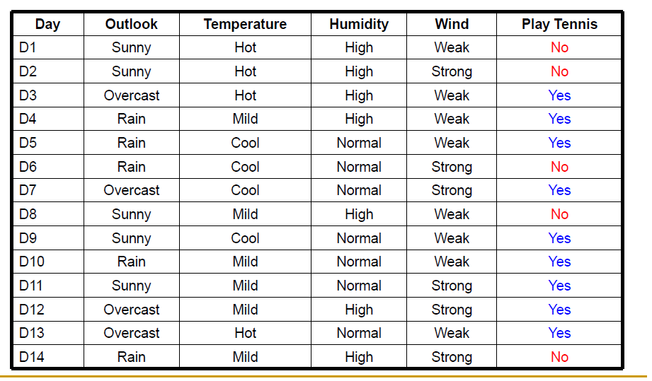
Atribute: OutLook
Values(Outlook) = Sunny, Overcast, Rain
Entropy(S) =$-\frac{9}{14}\log_{2}{\frac{9}{14}}{-}\frac{5}{14}\log_{2}{\frac{5}{14}}$= 0.94
Entropy($s_{Sunny}$) = $-\frac{2}{5}\log_{2}{\frac{2}{5}}{-}\frac{3}{5}\log_{2}{\frac{3}{5}}$ = 0.971
Entropy($s_{Overcast}$) = $-\frac{4}{4}\log_{2}{\frac{4}{4}}{-}0\log_{2}{\frac{0}{4}}$ = 0
Entropy($s_{Rain}$) = $-\frac{3}{5}\log_{2}{\frac{3}{5}}{-}\frac{2}{2}\log_{2}{\frac{2}{5}}$ = 0.971
Gain(S,Outlook) = Entropy(S) $-\frac{5}{14}$ Entropy($s_{Sunny}$) $-\frac{4}{14}$ Entropy($s_{Overcast}$) $-\frac{5}{14}$ Entropy($s_{Rain}$)
= 0.94 $-$ $\frac{5}{14}$0.971$-$ $\frac{4}{14}$0$-$ $\frac{5}{14}$0.971 = 0,2464
Atribute: Temp
Values(Temp) = Hot, Mild, Cool
Entropy(S) =$-\frac{9}{14}\log_{2}{\frac{9}{14}}{-}\frac{5}{14}\log_{2}{\frac{5}{14}}$= 0.94
Entropy($s_{Hot}$) = $-\frac{2}{4}\log_{2}{\frac{2}{4}}{-}\frac{2}{4}\log_{2}{\frac{2}{4}}$ = 1
Entropy($s_{Mild}$) = $-\frac{4}{6}\log_{2}{\frac{4}{6}}{-}\frac{2}{6}\log_{2}{\frac{2}{6}}$ = 0.9182
Entropy($s_{Cool}$) = $-\frac{3}{4}\log_{2}{\frac{3}{4}}{-}\frac{1}{4}\log_{2}{\frac{1}{4}}$ = 0.8113
Gain(S,Temp) = Entropy(S) $-\frac{4}{14}$ Entropy($s_{Hot}$) $-\frac{6}{14}$ Entropy($s_{Mild}$) $-\frac{4}{14}$ Entropy($s_{Cool}$)
= 0.94 $-\frac{4}{14}$ 1 $-\frac{6}{14}$ 0.9182 $-\frac{4}{14}$ 0.811 = 0.0289

Atribute: Humidity
Values(Humidity) = High, Normal
Entropy(S) =$-\frac{9}{14}\log_{2}{\frac{9}{14}}{-}\frac{5}{14}\log_{2}{\frac{5}{14}}$= 0.94
Entropy($s_{High}$) = $-\frac{3}{7}\log_{2}{\frac{3}{7}}{-}\frac{4}{7}\log_{2}{\frac{4}{7}}$ = 0.9852
Entropy($s_{Normal}$) = $-\frac{6}{7}\log_{2}{\frac{6}{7}}{-}\frac{1}{7}\log_{2}{\frac{1}{7}}$ = 0.5916
Gain(S, Humidity) = Entropy(S) $-\frac{7}{14}$ Entropy($s_{HIgh}$) $-\frac{7}{14}$ Entropy($s_{Normal}$)
=0.94$-\frac{7}{14}$0.9852$-\frac{7}{14}$0.5916 = 0.1516

Atribute: Wind
Values(Wind) = Strong, Week
Entropy(S) =$-\frac{9}{14}\log_{2}{\frac{9}{14}}{-}\frac{5}{14}\log_{2}{\frac{5}{14}}$= 0.94
Entropy($s_{Strong}$) = $1$
Entropy($s_{Week}$) = $-\frac{6}{8}\log_{2}{\frac{6}{8}}{-}\frac{2}{8}\log_{2}{\frac{2}{8}}$ = 0.8113
Gain(S,Wind) = Entropy(S) $-\frac{6}{14}$ Entropy($s_{Strong}$) $-\frac{8}{14}$ Entropy($s_{Week}$)
=0.94$-\frac{6}{14} 1-\frac{8}{14}$0.8113 = 0.0478
Information Gain :
Gain(S,Outlook) = 0,2464
Gain(S,Temp) = 0.0289
Gain(S,Humandity) = 0.1516
Gain(S,Wind) = 0.0478

Because the Outlook attribute has the highest Information Gain, we choose this attribute to divide the data set with Outlook as the root and the Sunny, Overcast, Rain nodes.
It's clear that with the Overcast value, everyone can play tennis, so we can set up the Overcast - Yes branch.
Next, we calculate the Information Gain between the sunny value and other attributes.
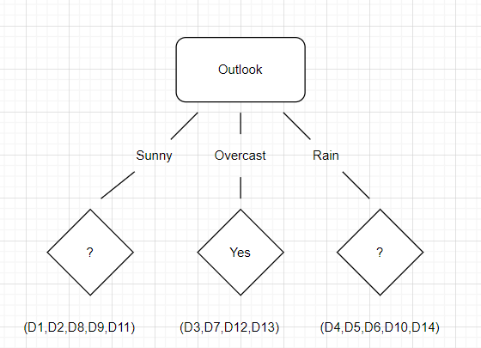

Create Table D1,D2,D8,D9,D11:
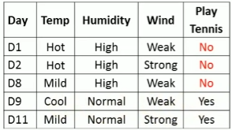
Atribute: Temp
Values(Temp) = Hot, Mild, Cool
Entropy($s_{Sunny}$) = $-\frac{2}{5}\log_{2}{\frac{2}{5}}{-}\frac{3}{5}\log_{2}{\frac{3}{5}}$ = 0.97
Entropy($s_{Hot}$) = 0
Entropy($s_{Mild}$) = 1
Entropy($s_{Cool}$) = 0
Gain($s_{Sunny}$,Temp) = Entropy(S) $-\frac{2}{5}$ Entropy($s_{Hot}$) $-\frac{2}{5}$ Entropy($s_{Mild}$) $-\frac{1}{5}$ Entropy($s_{Cool}$)
=0.97$-\frac{2}{5} 0 -\frac{2}{5}1$ $-\frac{1}{5} 0$ = 0.57

Atribute: Humidity
Values(Humidity) = High, Normal
Entropy($s_{Sunny}$) = $-\frac{2}{5}\log_{2}{\frac{2}{5}}{-}\frac{3}{5}\log_{2}{\frac{3}{5}}$ = 0.97
Entropy($s_{High}$) = $0$
Entropy($s_{Normal}$) = 0
Gain($s_{Sunny}$, Humidity) = Entropy(S) $-\frac{3}{5}$ Entropy($s_{High}$) $-\frac{3}{5}$ Entropy($s_{Normal}$)
=0.97 $-\frac{3}{5} 0-\frac{3}{5} 0=0.97$

Atribute: Wind
Values(Wind) = Strong, Week
Entropy($s_{Sunny}$) = $-\frac{2}{5}\log_{2}{\frac{2}{5}}{-}\frac{3}{5}\log_{2}{\frac{3}{5}}$ = 0.97
Entropy($s_{Strong}$) = $1$
Entropy($s_{Week}$) = $-\frac{1}{3}\log_{2}{\frac{1}{3}}{-}\frac{2}{3}\log_{2}{\frac{2}{3}}$ = 0.9183
Gain($s_{Sunny}$,Wind) = Entropy(S) $-\frac{2}{5}$ Entropy($s_{Strong}$) $-\frac{3}{5}$ Entropy($s_{Week}$)
= 0.97$-\frac{2}{5} 1-\frac{3}{5}$0.9183 = 0.0192

Information Gain :
Gain($s_{Sunny}$,Temp) = 0.57
Gain($s_{Sunny}$, Humidity) = $0.97$
Gain($s_{Sunny}$,Wind) = 0.0192

Because the Information Gain characteristic between Sunny and Humidity is the greatest, the branch from Sunny will be Humidity.
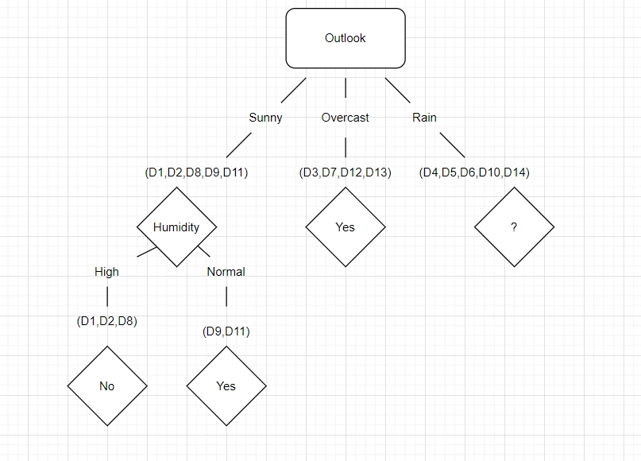

Similarly, at the Rain value we have Table D4,D5,D6,D10,D14 :
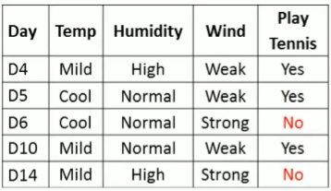
Atribute: Temp
Values(Temp) = Hot, Mild, Cool
Entropy($s_{Rain}$) = $-\frac{3}{5}\log_{2}{\frac{3}{5}}{-}\frac{2}{2}\log_{2}{\frac{2}{5}}$ = 0.97
Entropy($s_{Hot}$) = 0
Entropy($s_{Mild}$) = $-\frac{2}{3}\log_{2}{\frac{2}{3}}{-}\frac{1}{3}\log_{2}{\frac{1}{3}}$ = 0.9183
Entropy($s_{Cool}$) = 1
Gain($s_{Rain}$,Temp) = Entropy(S) $-\frac{0}{5}$ Entropy($s_{Hot}$) $-\frac{3}{5}$ Entropy($s_{Mild}$) $-\frac{2}{5}$ Entropy($s_{Cool}$)
= = 0.97$-\frac{0}{5} 0-\frac{3}{5}$ 0.9183 ) $-\frac{2}{5}$ 1 = 0.0192

Atribute: Humidity
Values(Humidity) = High, Normal
Entropy($s_{Rain}$) = $-\frac{3}{5}\log_{2}{\frac{3}{5}}{-}\frac{2}{2}\log_{2}{\frac{2}{5}}$ = 0.97
Entropy($s_{High}$) = $1$
Entropy($s_{Normal}$) = $-\frac{2}{3}\log_{2}{\frac{2}{3}}{-}\frac{1}{3}\log_{2}{\frac{1}{3}}$ = 0.9183
Gain($s_{Rain}$, Humidity) = Entropy(S) $-\frac{2}{5}$ Entropy($s_{High}$) $-\frac{3}{5}$ Entropy($s_{Normal}$)
= 0.97$-\frac{3}{5} 1$ $-\frac{3}{5}$ 0.9183 = 0.0192

Atribute: Wind
Values(Wind) = Strong, Week
Entropy($s_{Rain}$) = $-\frac{3}{5}\log_{2}{\frac{3}{5}}{-}\frac{2}{2}\log_{2}{\frac{2}{5}}$ = 0.97
Entropy($s_{Strong}$) = $0$
Entropy($s_{Week}$) = $0$
Gain($s_{Sunny}$,Wind) = Entropy(S) $-\frac{2}{5}$ Entropy($s_{Strong}$) $-\frac{3}{5}$ Entropy($s_{Week}$)
= 0.97$-\frac{2}{5} 0-\frac{3}{5}$0 = 0.97

Information Gain :
Gain($S_{Rain}$,Temp)=0.0192
Gain($S_{Rain}$,Humandity)=0.0192
Gain($S_{Rain}$,Wind)=0.97
We can observe that the Information Gain of Rain and Wind is the biggest, hence the branch associated with Rain will be Wind.

At last, the Decision Tree that follows is obtained:
